AI FAQ Assistant AI -AI-powered FAQ and customer support automation.

Description
The AI FAQ Assistant is a powerful, secure, and intelligent REST API platform developed to simplify FAQ creation, user authentication, and AI-driven content management. Built using Node.js and Express.js, the application uses MongoDB as its primary database, along with Mongoose ODM for efficient data modeling and schema validation.
Security is a key part of the architecture, using JWT (JSON Web Tokens) to manage stateless user sessions and protect routes, along with b crypt for secure password hashing. The back-end manages resource-intensive tasks such as automated FAQ generation, semantic search operations, and dynamic context processing. It also includes comprehensive centralized error handling and response status sanitation to prevent database information leaks, handle errors effectively, and maintain reliable system performance.

Scenario-Based Case Study

Background
Priya is a customer support operations manager who deals with a large backlog of repetitive user queries. However, she faces difficulties in organizing inquiries, categorizing topics, preparing accurate summaries, and efficiently monitoring trends in client questions.
Problem
- Difficulty creating and maintaining updated documentation workflows.
- Limited insight into semantic search keywords and the ability to resolve queries quickly.
- Time-consuming manual efforts required to prepare responses for complex support questions.
- Absence of a centralized database permission system to protect private documentation from unauthorized public modifications.

Solution
The AI FAQ Assistant back-end provides a centralized and secure API layer that separates application business logic from fronted delivery mechanisms. It incorporates internal verification frameworks to manage specialized services for content generation, category keywords, database storage, and automated text inference processes.

Usage
- Authenticated Creator Usage: Creates and manages profiles, requests immediate AI assistance, prepares official FAQ structures, and modifies or deletes records created by themselves.
- Public/Consumer Usage: Accesses general listing endpoints to view published articles and performs localized semantic searches using query parameters.

Outcome
By shifting workflow management to a reliable backend system, operational delays are significantly reduced. Data consistency is ensured through automated schema validation, while security tokens allow only the original authors to modify their documents. High-performance indexing also enables fast and real-time data retrieval.

1. Software Requirements
- Operating System: Windows 10/11, mac OS, or Linux, providing support for cross-platform development and operation.
- Node.js (v18 or above): Runtime environment used to execute server-side logic and manage routing infrastructure.
- npm (v9 or above): Node package manager responsible for managing project dependencies and required packages.
- Express.js (v4/v5 Ecosystem): Lightweight web framework used to create backend routes and Restful API endpoints.
- MongoDB / Mongoose ODM: No-SQL document database and ODM used to store application users and organized data entities.
- Postman / Thunder-client: API testing tools used to verify schema validation and responses across protected administrative routes.
- Code Editor: Visual Studio Code or another similar integrated development environment (IDE) for writing and managing the project code.
2. Hardware Requirements
- Processor: Intel Core i5 (8th Generation or newer), AMD Ryzen 5, or an equivalent processor.
- RAM: At least 8 GB of memory, with 16 GB recommended for running multiple MongoDB processing instances simultaneously.
- Storage: A minimum of 1 GB of available disk space for the project workspace.

Epic-1: Project Architecture

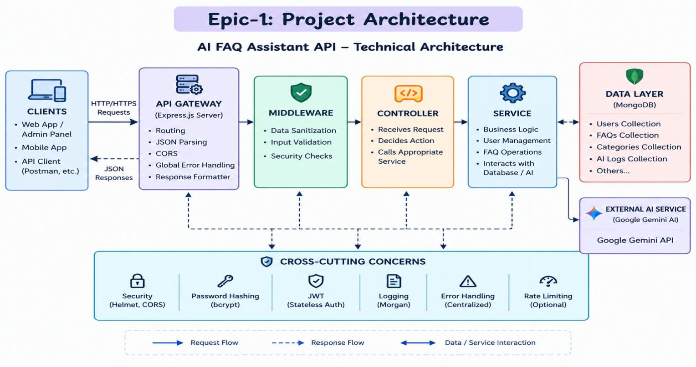

The AI FAQ Assistant uses a layered server architecture to handle requests. Incoming requests are first checked and filtered, and then they interact with the data services to process and return the required information.

Components Definition
- Interface: Tools like Postman send requests to different API routes and receive JSON data.
- Express Server Gateway: Receives requests, handles GET, POST, PUT, and DELETE, reads JSON data, and manages CORS.
- Authentication Middleware: Checks the user token and verifies whether the user has permission to access protected routes.
- Services: Handles the main business logic, such as user sessions and FAQ operations.
- Database Layer: Mongoose connects the application with MongoDB to store and retrieve data.
- AI Service: Google Gemini API is used to answer questions and generate FAQ topics automatically.

Entity-Relationship (ER) Diagram Description

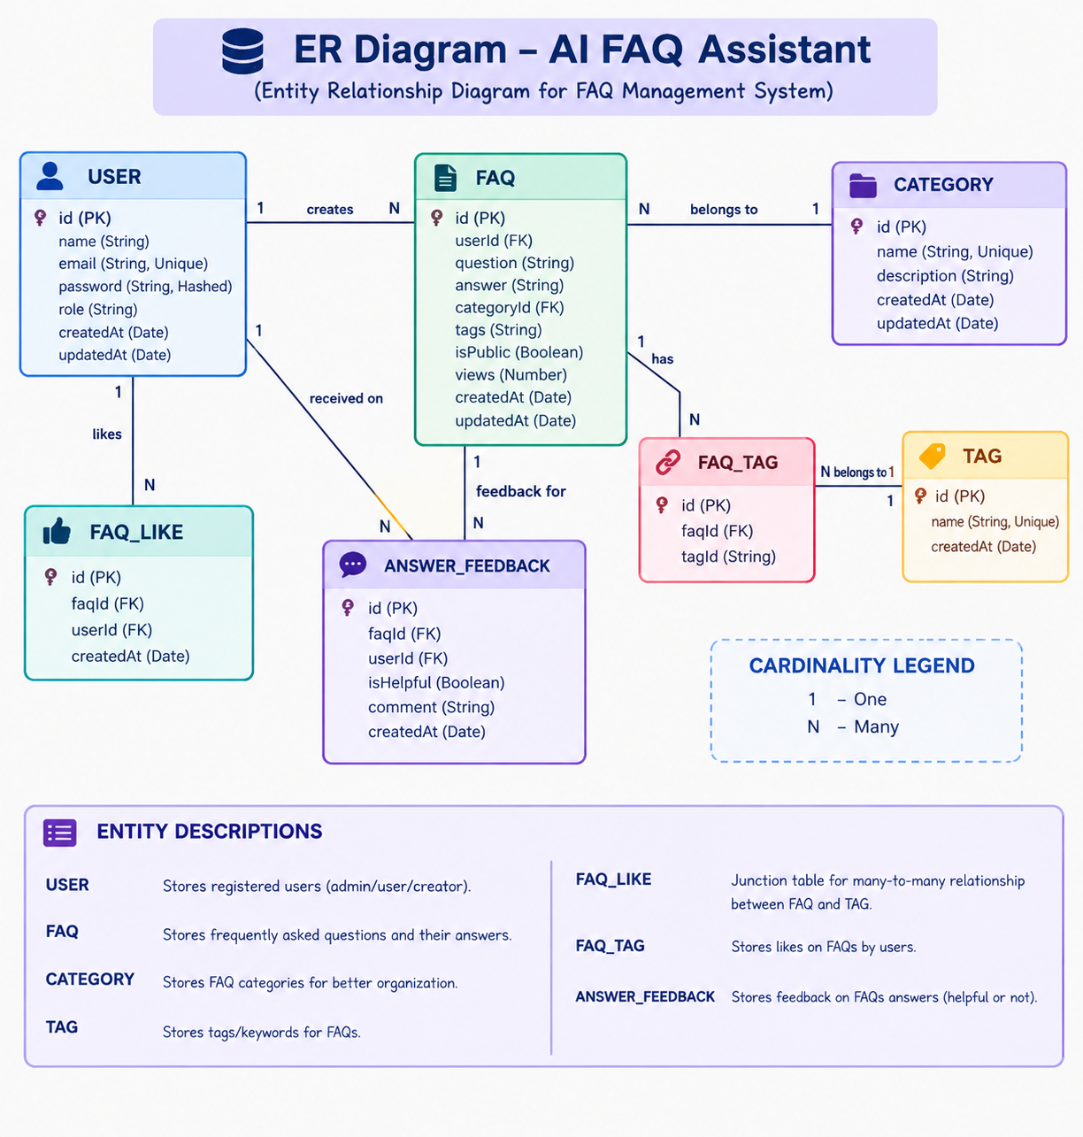

The back-end database consists of multiple MongoDB collections connected through logical references to maintain user authentication, FAQ management, AI-generated content, and category organization.

1. User Entity
- _id (Primary Key - Object-id)
- name (String, Required)
- email (String, Required, Unique)
- password (String, Hashed, Required)
- role (String, Default: "user")
- created At
- updated At

2. FAQ Entity
- _id (Primary Key - Object Id)
- question (String, Required)
- answer (String, Required)
- category (String, Required)
- created By (Foreign Key referencing User Collection)
- created-At
- updated-At

3. AI Generation Entity (Logical)
(Generated dynamically using Google Gemini AI before persistence.)
- topic (String)
- generatedQuestion (String)
- generatedAnswer (String)
- generatedCategory (String)
- generatedAt

4. Category Entity (Logical)
- categoryName (String)
- description (String)
- totalFAQs (Number)

Key Structural Mappings
- User → FAQ (One-to-Many):
A registered user can create and manage multiple FAQ records.
- Category → FAQ (One-to-Many):
Each category can contain multiple FAQ documents.
- User → AI Generated FAQ (One-to-Many):
A user can generate multiple AI-assisted FAQs, which may later be saved into the FAQ collection.
- FAQ → Search Results (Logical Relationship):
Search queries retrieve matching FAQ documents using keyword and semantic matching.

Key Features
- JWT Authentication: Uses secure tokens to protect private API routes.
- AI FAQ Generation: Google Gemini AI creates questions, answers, and topic suggestions.
- FAQ Search: Helps users quickly find FAQs using keywords.
- CRUD Operations: Allows users to Create, Read, Update, and Delete FAQs.
- Category Management: Organizes FAQs into different categories.
- Password Encryption: Uses b crypt to securely store passwords.
- Error Handling: Provides standard error messages when something goes wrong.
- Schema Validation: Checks that the data is correct before saving it.
- RESTful API: Uses Express.js routes to provide organized backend services.
- MongoDB Integration: Stores application data in MongoDB using Mongoose.

Roles and Responsibilities

Admin
- Manages all users.
- Can view, edit, and delete any FAQ.
- Checks AI-generated content.
- Manages FAQ categories.
- Has full system access.
Content Creator
- Creates new FAQs.
- Edits and deletes their own FAQs.
- Uses AI to generate FAQs.
- Organizes FAQs into categories.
Authenticated User
- Views public FAQs.
- Searches FAQs using keywords.
- Gets AI-assisted answers.
- Can view their profile.
Public User
- Can view published FAQs.
- Can search FAQs.
- Cannot create, edit, or delete FAQs.
User Flow

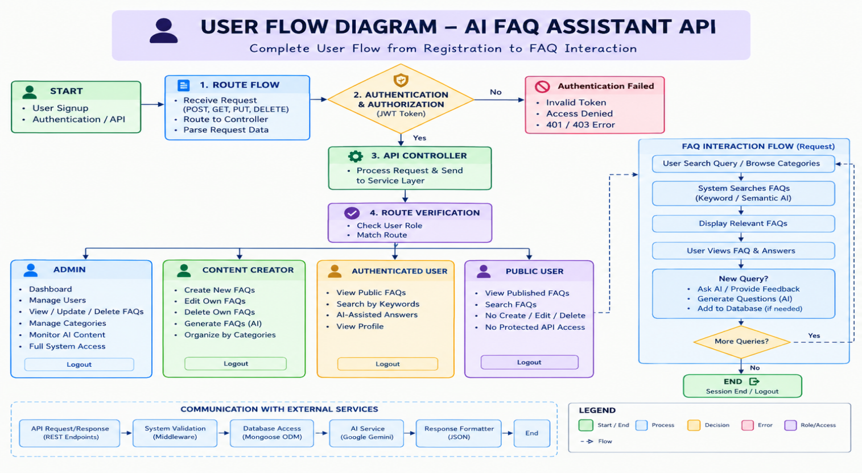

MVC Architecture Pattern
The system architecture structures its source configuration layers around the Model-View-Controller design pattern to completely decouple components:
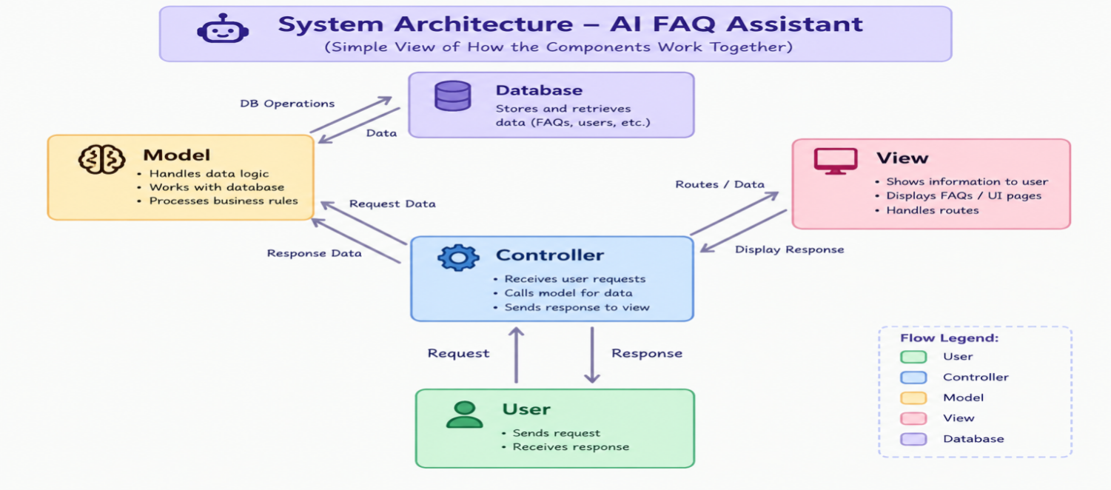
Model Layer – Data
- Defines the structure of the data using Mongoose schema s.
- Specifies fields, data types, rules, and default values.
- Stores and retrieves data from MongoDB.
Controller Layer – Processing
- Acts as the main processing layer.
- Receives requests from the routes.
- Checks the request and performs the required operation.
- Communicates with models or services.
- Sends the result back as a JSON response.
View Layer – API Routes
- Since this is a back-end API, there is no traditional web page view.
- The API routes act as the View layer.
- Routes receive requests and connect them to the correct controller.
- Example: GET /faqs → FAQ Controller.

Epic 2: Project Setup and Configuration

Creating Project Folder
- Create a new folder with your <project name>.
- Inside that folder, create a new subfolder named src.
- Now open that folder in VS Code.
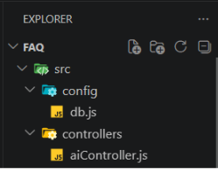

Server Setup (npm init)
Open your root folder terminal in VS Code and run:
Bash

npm init -y
npm install express mongoose dotenv cors jsonwebtoken bcrypt @google/genai

File and Folder Structure Matrix
Plaintext
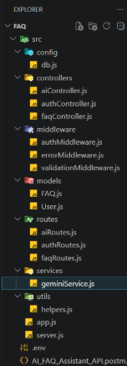

Epic 3: Back-end Development

Core System Script Implementations

1. Gateway Server Node (src/server.js)
This main entrance mechanism aggregates environment variables, triggers database listeners, and binds network listeners to active environment ports:
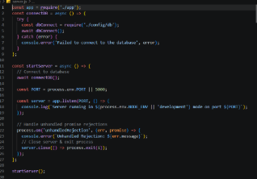
2. Gateway Express Setup (src/app.js)
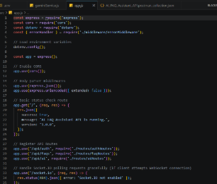

3. Security Access Middleware (src/middleware/authMiddleware.js)
Intercepts incoming target queries, extracts transmission header authorization records, and validates token identity context claims:
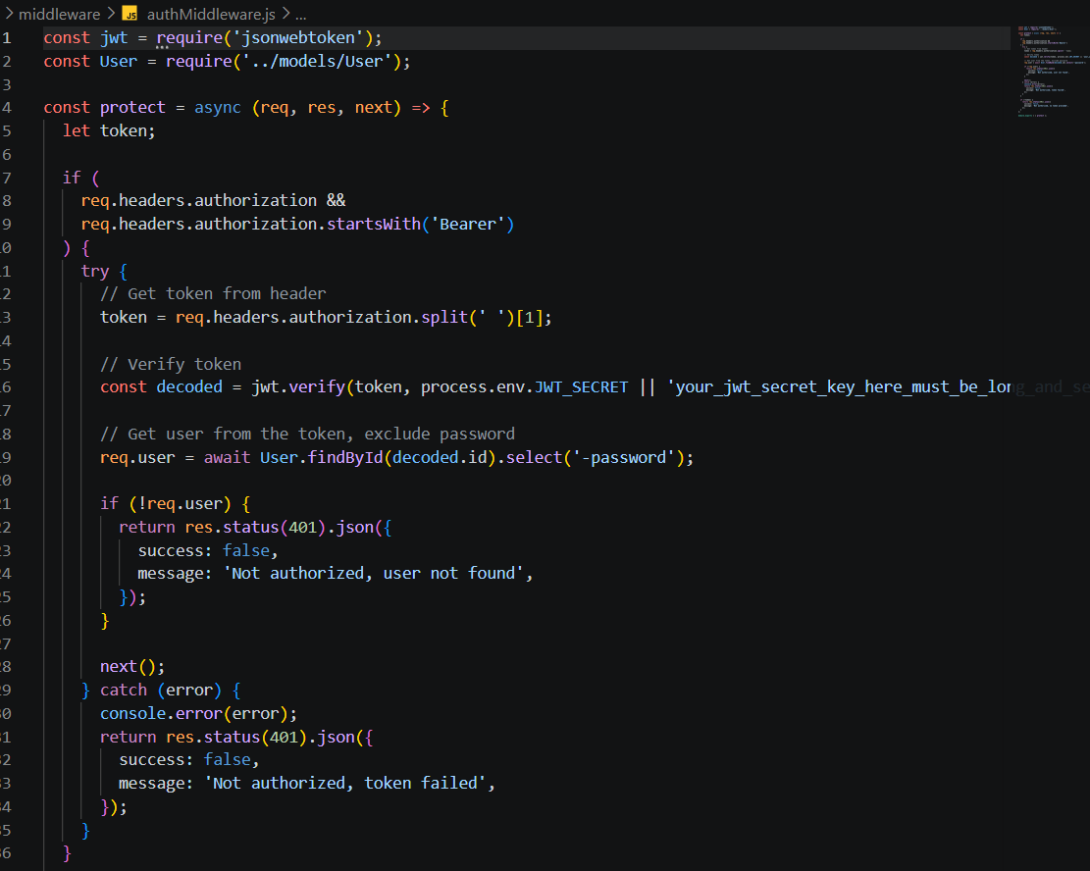

4. Centralized Error Handler Middleware (src/middleware/errorMiddleware.js)



Epic 4: Database Configuration

Mongoose Schema Definitions

1. Identity Resource Document Schema (src/models/User.js)
Enforces profile field criteria validations and hooks password hashing steps prior to user document persistence:
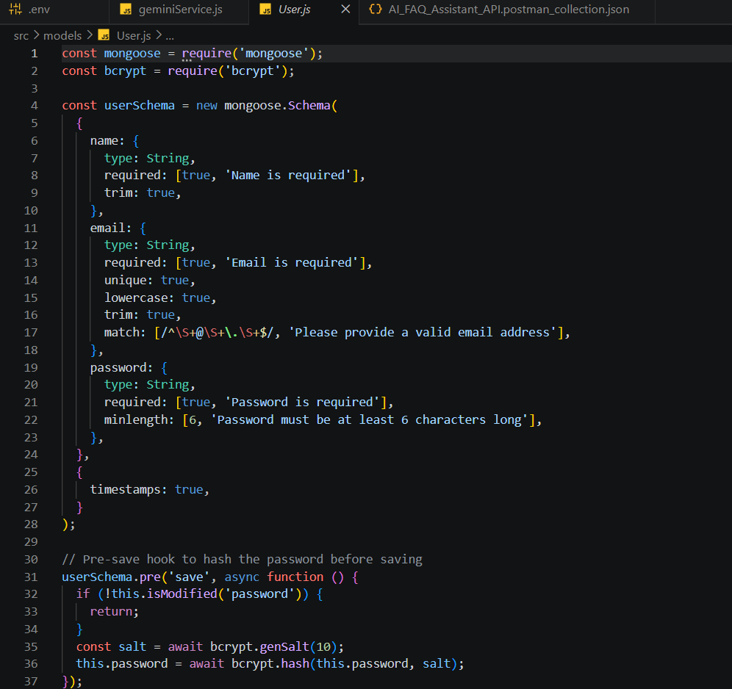

2. FAQ Resource Document Schema (src/models/FAQ.js)
Models core properties and maps a distinct relational reference link back to the source creator document:



API Router Interface Endpoints

Public Authentication Operations (src/routes/authRoutes.js)



2. Protected FAQ Operations (src/routes/faqRoutes.js)

JavaScript



3. AI Automation Operations (src/routes/aiRoutes.js)



Epic 5: Project Executions

Running the API Application
- Install Postman or Thunder-client (VS Code extension).
- Start the back-end development server environment parameters:
Bash
npm run dev

API Testing Specification Demo
To verify operational structural integrity via execution endpoints, map endpoints using the configurations below:

1. Identity On-boarding Path Registration
- Route: POST /api/auth/register
- Access: Public
- Payload Request Body JSON:
JSON
{
"name":"priyadharshini",
"email":"priyadharshini123@gmail.com",
"password":"priya12345"
}
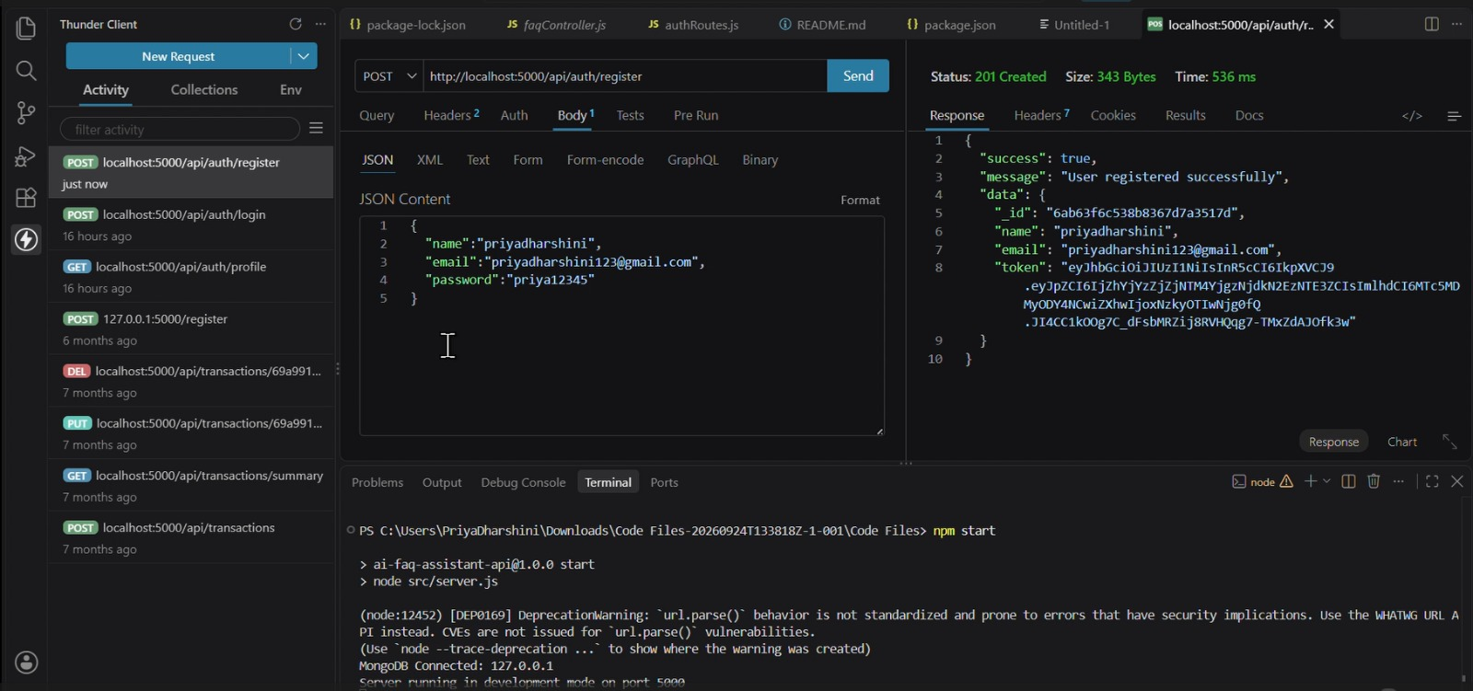

Profile Login Verification Quey

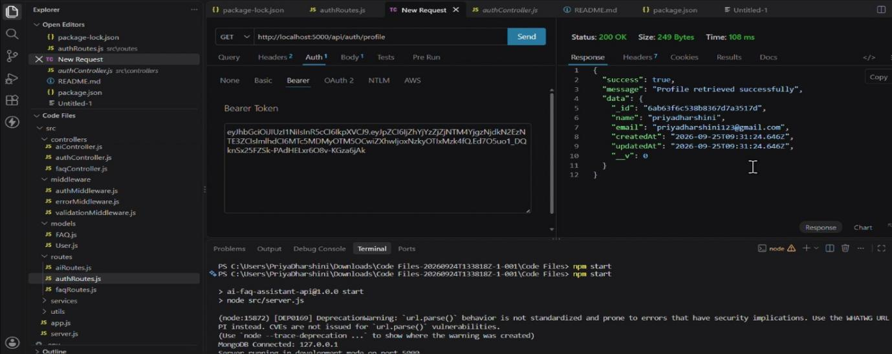
- Route: POST /api/auth/login
- Access: Public
- Payload Request Body JSON:
JSON
{
"email":"priyadharshini123@gmail.com",
"password":"priya12345"
}

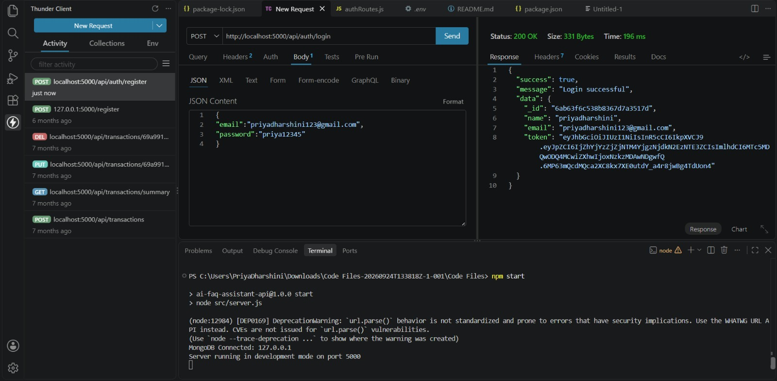

3. Resource Entity Creation (FAQ)
- Route: POST /api/faqs
- Access: Private (Bearer <JWT Token>)
- Payload Request Body JSON:
JSON

{
"question":"what is python",
"answer":"python is a high level programming language used for software development, data science, Artificial intelligence and automation.",
"Category":"Technology"
}

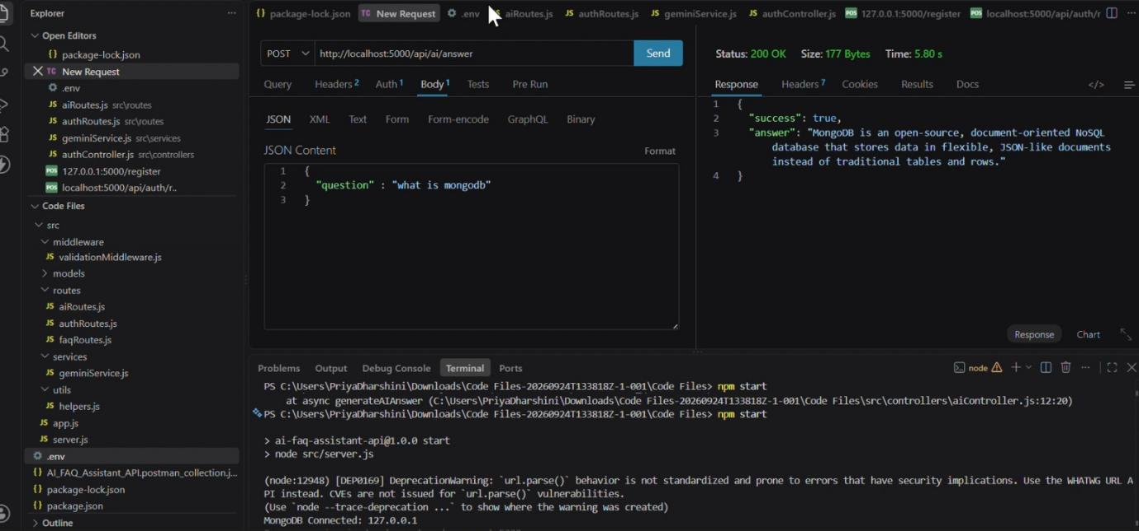

4. Keyword Resource Entity Fetching (Search)
- Route: GET /api/faqs/search?q=configure
- Access: Public

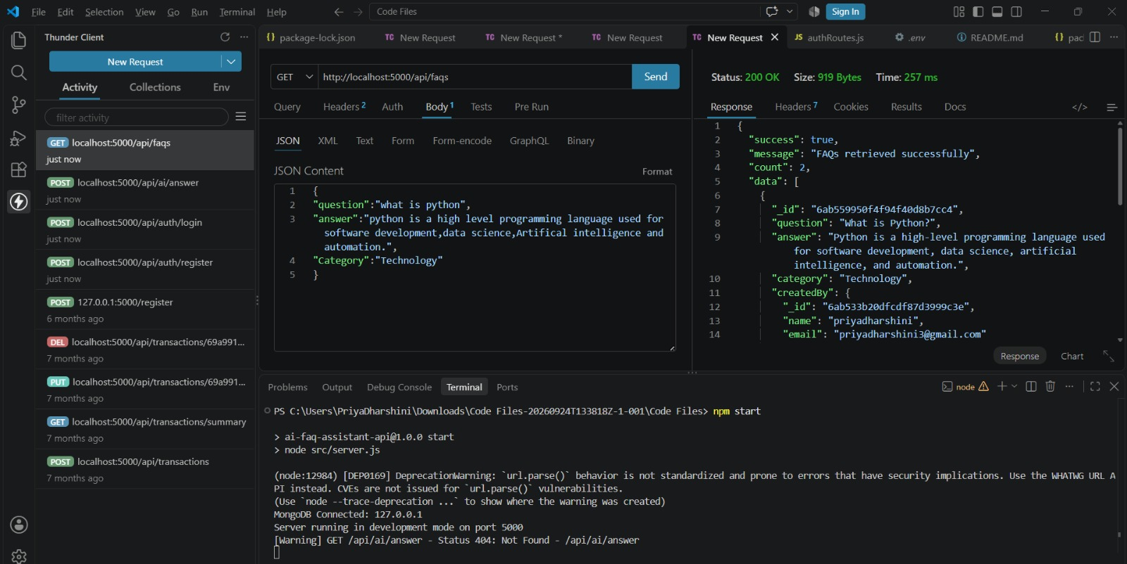

5. AI Intelligent Content Automation (Generate FAQ Pair)
- Route: POST /api/ai/generate-faq
- Access: Private (Bearer <JWT Token>)
- Payload Request Body JSON:
JSON
{
"topic":"mongodb"
}
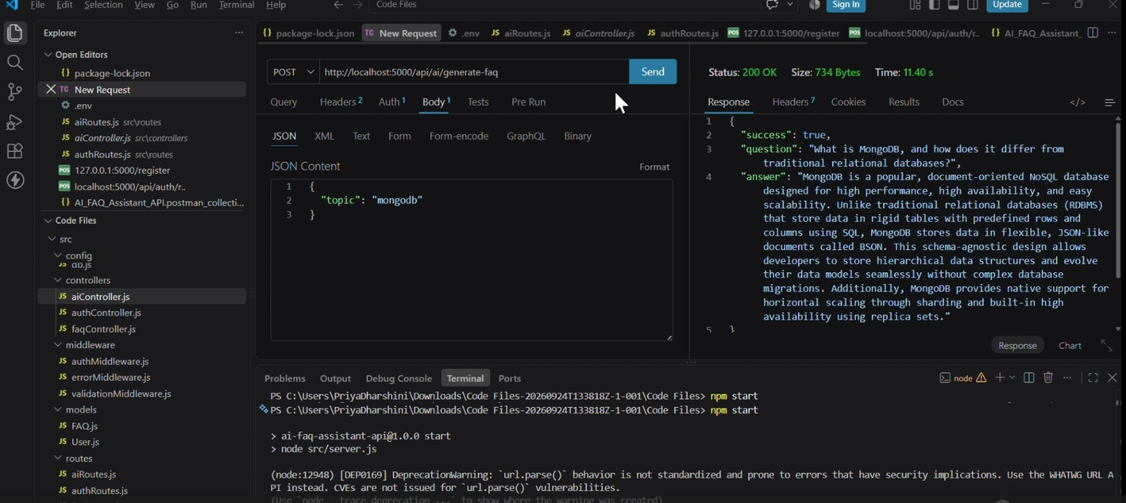

DEMO LINK:

Code :

